**MAST instructions**

**Preparation**

Read carefully the information on the PowerPoint slides.

**Preparation test day**

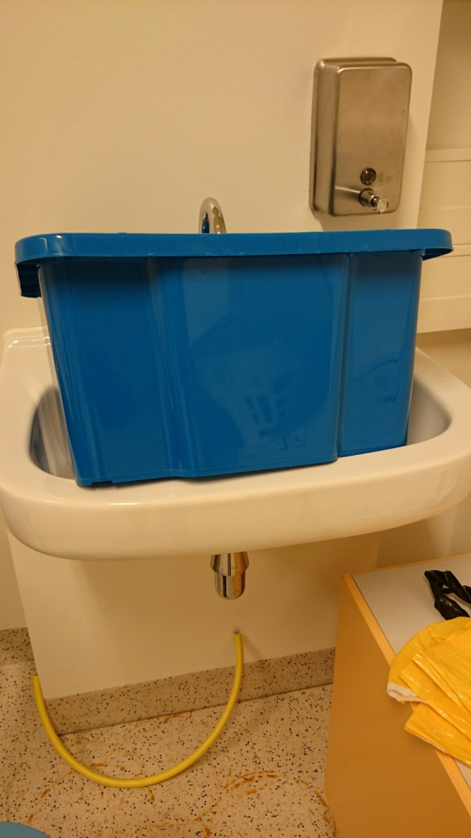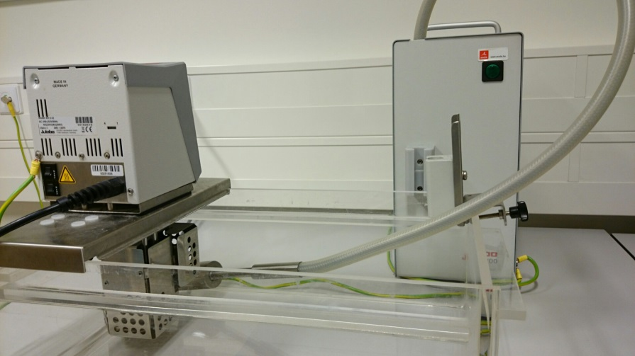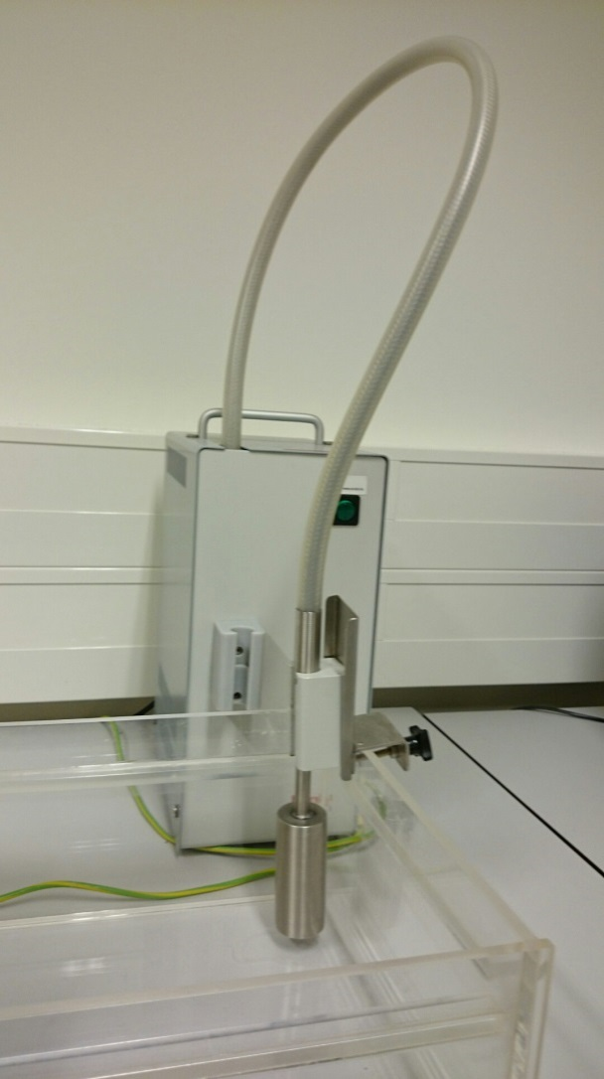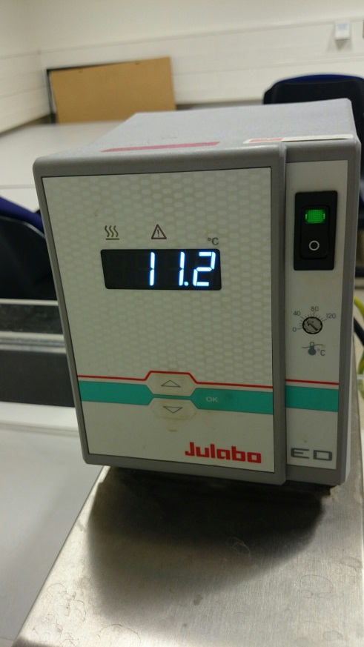

**1**

**2**

**3**

**4**

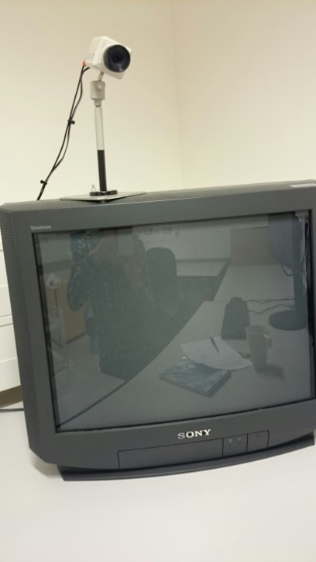

**5**

1. Take clean water
2. Fill the box up until the edge at the outside and place the cooling device in the corner
3. Switch on the cooling device
4. Switch on the temperature device and select the correct temperature by using the arrows: Stress = 2°C; Control is 36°C

Then press ok for several seconds until the device starts cooling.

1. Switch on the camera and position it correctly.

**Test day**

1. Take water
2. Fill the box until the edge at the outside and place the cooling device in the corner
3. Switch on the cooling device
4. Switch on the temperature device and select the correct temperature by using the arrows Stress = 2°C; Control is 36°C

Then press ok for several seconds until device starts.

1. Switch on the camera and position it correctly.

Go through the power point slides together with the participant while reading the information for the participant out-loud (ensuring that they really pay attention to the instructions). Ask regularly whether the instructions and the upcoming task are clear.

Have the participant sign the extra informed consent for the videotaping by tapping the appropriate box.

**Note related to the content of the MAST instructions**

It is stated that

1. the task will take about 12min,
2. there will be a rest period, and
3. that the computer will randomly decide the duration of the trials.

In reality, however,

1. it will take exactly 10min; this is misleadingly stated because then you can take a saliva sample/subjective stress measure while the participants still thinks the task will continue afterwards, hence excluding the potential influence of feeling relieved of knowing the task has come to an end,
2. the rest period is fictitious for the aforementioned reason and after the saliva sample/subjective stress measure has been obtained the task is thus ended,
3. there is a single fixed order; once the instructions have been shown, the powerpoint presentation will run automatically.

**Note related to the execution of the MAST**

**The counting**

During counting trials, it is essential that the participant engages in the challenging task and that the experimenter *does nothing more than to give negative feedback*. Importantly, *no positive or confirmatory feedback* should be given. **These are typical examples of negative feedback:**

1. If a mistake is made, say: “Incorrect. Start again”.
2. Participants should correctly pronounce the numbers in English. Correct them if they don’t. For example, instruct them to say “two-thousand forty-three” and not “twenty-forty-three”.
3. If participants are good / don’t really have a problem with the counting, provide negative feedback by asking to count faster (“Try to count as fast as possible.”, “Could you please count faster”).
4. Sometimes people just stop counting and wait until the end of that trial. Ask participants to start over from 2043 (“Please start counting again from 2043”).
5. Only if the participant is REALLY unable to perform this task, you can by way of exception allow them to start at a 3-digit number (e.g., 768), which is easier. If that goes well, go back to a 4-digit number (e.g., 2043).
6. Avoid any positive of confirmatory feedback (e.g., nodding when they are counting correctly).

**Hand in the water**

During hand immersion trials, it is essential that the participant immerses their hand correctly and keeps looking at the camera/television. Many participants will find it difficult to hold the hand in the water, especially during the first trial. As the experimenter, try to ensure that they perform the task correctly. **These are typical moments at which you have to intervene:**

1. Always check whether the whole hand is in the water, including the wrist. If not, provide feedback (“Please hold your hand deeper in the water”) & check during the whole trial.
2. If they look at you, the hand, or elsewhere, say: “Please look straight in the camera / at the television screen”.
3. If participants start to talk to you or start to swear it is often to distract themselves from the unpleasantness. Don’t answer them and say “Please focus on the task”.
4. If participants say that they can’t hold it anymore respond by saying “Please keep your hand in the water until you hear the sound”. Of course, there is a fine line in that they have the right to stop at any time, so don’t force them in any way but try to encourage them without being too friendly.
5. If they retract their hand:
   1. ask them to put it in the water again (“Please put your hand in the water”).
   2. If they really don’t want, tell them that it is ok for this trial to keep it out the water but that they should again put it in the water the next trial.

If you have any further questions, please feel free to contact Tom Smeets ([tom.smeets@maastrichtuniversity.nl](mailto:tom.smeets@maastrichtuniversity.nl))